AIPP LAB 7
Name: SYEDA FARHATH UMAMA
Hall Ticket No.: 2503B05143 ___________________________________________________
Completed this Assignment using Cursor Al Integration.
Task 1:
Paste a function with a missing colon and let AI fix it.
CODE:
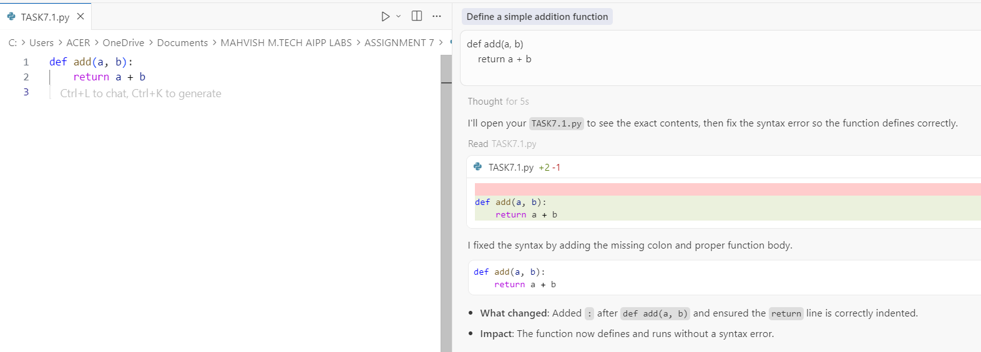
- AI identified the missing colon (:) in the function definition and corrected the syntax so Python can interpret the function properly.
Task 2:
Identify and fix a logic error in a loop that causes infinite iteration. AI fixes increment/decrement error.
CODE:
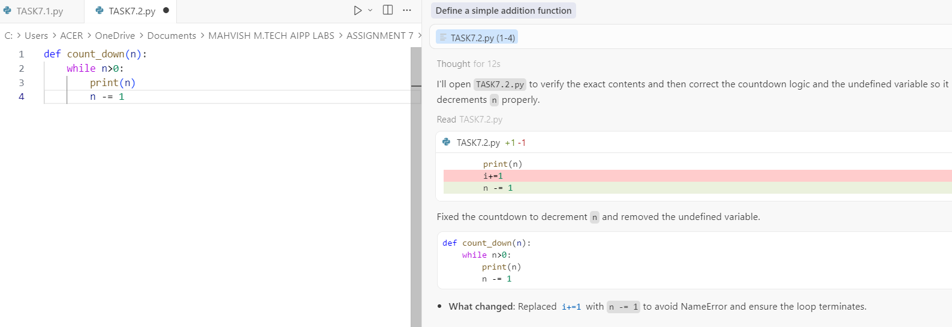
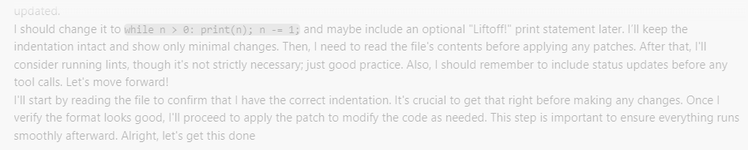
Task 3:
Debug a runtime error caused by division by zero. Let AI insert try-except.
CODE:
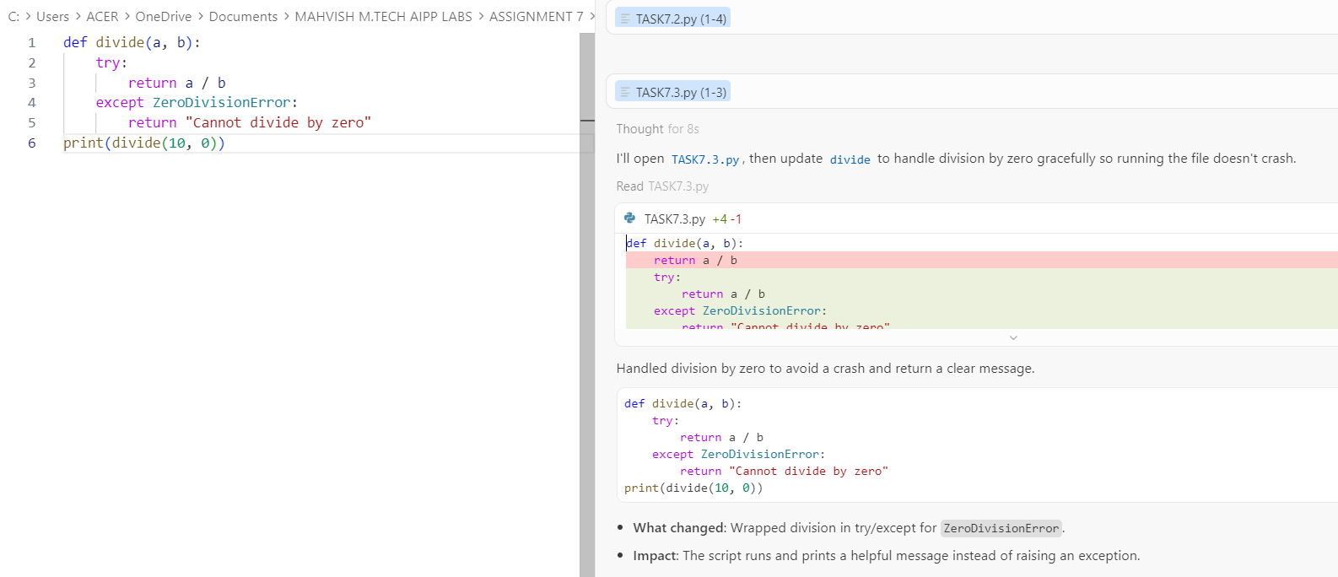
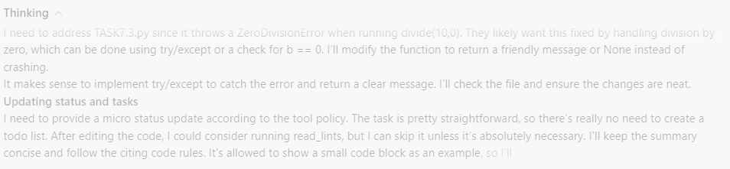
- AI caught the runtime error and added try-except to safely handle cases where b = 0.

Task 4:
Provide a faulty class definition (missing self in parameters). Let AI fix it.
CODE:
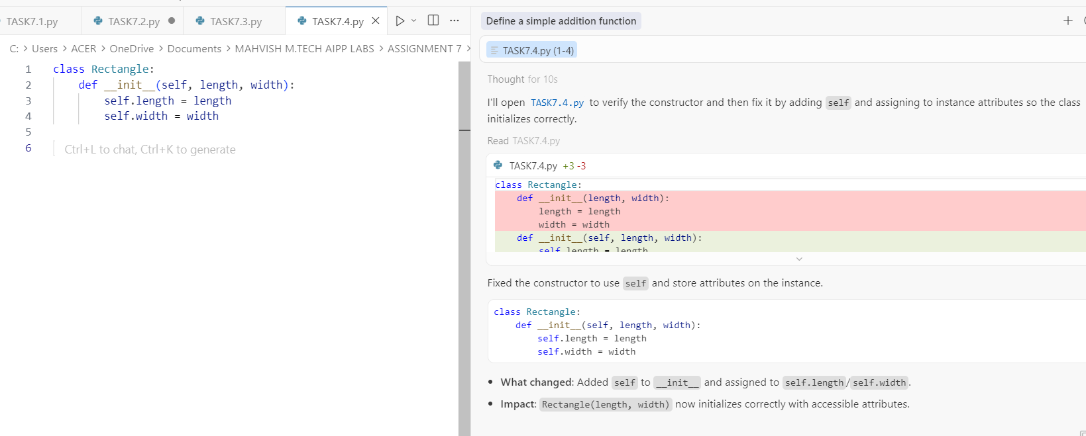
- AI added self as the first parameter and used self.length and self.width to correctly store instance attributes.

Task 5:
Access an invalid list index and use AI to resolve the Index Error.
CODE:
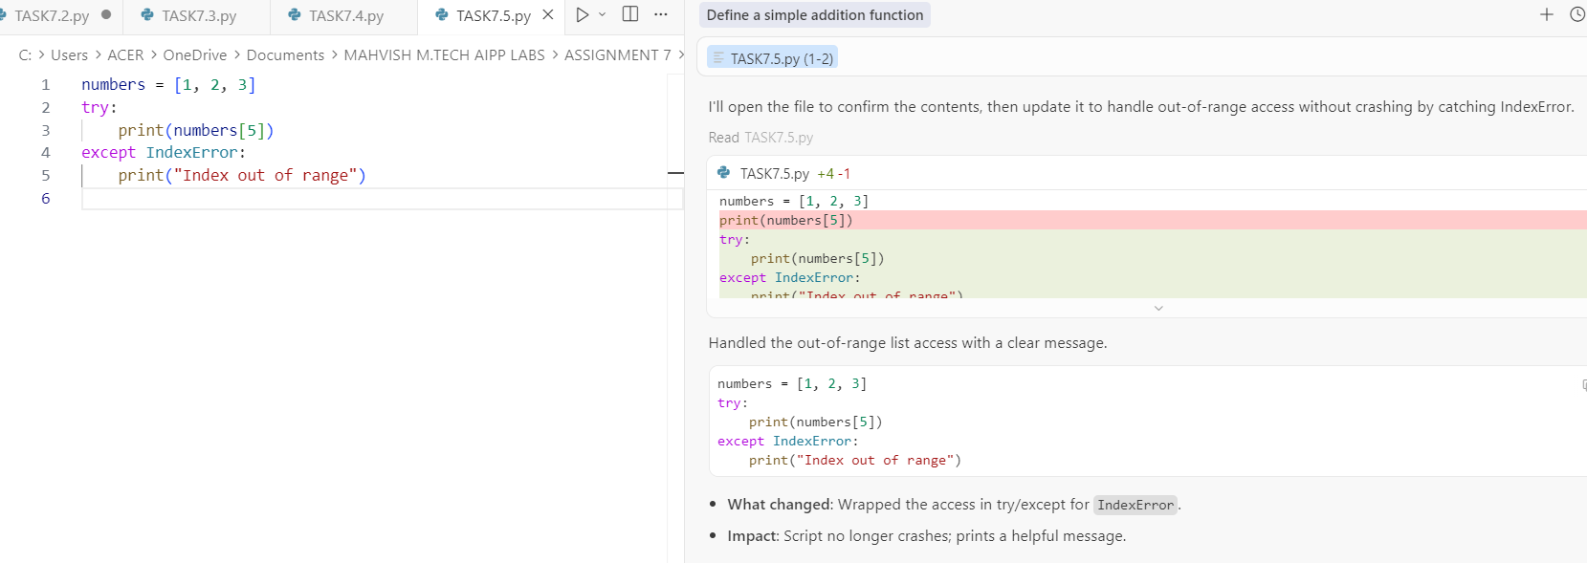
- AI recommended checking len(my_list) before accessing the index to prevent IndexError.
__________________________________________________________

